Review On Mitra Placement Portal

Project Guide – Prof. Dr. Nikoo Khalsa

Training and Placement Officer, Prof. Ram Meghe Institute of Technology and Research, Badnera

Shravani Kolhe , Devalya Gite , Priyanshu Khodke , Vaibhavi Lakde

# Electronics and Telecommunication, Prof. Ram Meghe Institute of Technology and Research, Prof. Ram Meghe Square, Anjangaon Bari Road, Badnera, Amravati, Maharashtra, India.



Abstract : The system focuses on automation of conventional training and placement management system. This system can be used as an application for the Training &Placement Officers in the college to manage the student information with regard to placement and providing assistance using the assistance portal where students can post their query to the TPO and coordinators. Providing Student login helping them to update their personal and educational information in a form which will be added to the database and upload a resume and providing them with preparation materials for placements. An additional feature of the portal is a Company Tab which will be providing assistance to the companies to shortlist the students as per their eligibility criteria. It reduces the manual work and consumes less paperwork to reduce the timeOnline Training and Placement system automates activities of Training and placement cell and place the best coordination between student. It provide student community to use collective intelligence to increase selection ratio and eases out process of creation of management information automatically. Online Training and Placement focuses on automation of placement cell. Authorizing the CV,communicating about the various job openings to the student community, managing the corporate relationship for inviting them for the placements as well other activities, monitoring the progress of the selection process and communicating with different user The Placement Management System is developing as an attempt to Keep track of companies and students by restricting such a large database to that of a specific class of students or companies.The System provides the facility of viewing both the personal and academic information of the student and company You can also search for eligible students or companies, or admins can insert or delete Records. in this paper we are explaining how the management system was built using Android studio , HTML ,CSS ,XML and JavaScript etc.

# INTRODUCTION

The "MITRA Placement Portal" is a comprehensive web-based platform designed to optimize the placement process at

***

PRMIT&R. This project addresses the need for a streamlined and efficient system to manage student data, facilitate seamless interaction with recruiters, and track placement records effectively. The portal aims to enhance transparency, accessibility, and administrative efficiency in managing campus placements. In Today's Dynamic Job market, the Effective Placement of students from Educational Institutions into suitable career opportunities is paramount. The Mitra Placement Portal emerges as a robust solution designed to streamline and enhance the entire placement process for both students and educational institutions alike. This introduction delves into the core functionalities and benefits of the Mitra Placement Portal, focusing on four key aspects: Student Registration and Database Creation, Exporting Data into Excel and Applying Filters, Tracking Placement Records, and Verification of Student Data. The main purpose of this project is to establish and launch a thorough placement portal with the goal of enhancing employability. With the help of this project, we hope to create an accessible web portal that connects employers and job seekers and offers useful resources and tools to enhance applicants' preparation for work. Our project's goals include developing and creating the portal, putting user engagement strategies into action, evaluating how it affects employability metrics, and developing long-term, sustainable practices. Placement management system helps the training and placement officers to overcome the difficulty in keeping records of hundreds and thousands of students and searching the eligible students for recruitment, based on various eligibility criteria of different companies. It helps in effective and efficient utilization of the hardware and the software resources.

1. LITERATURE SURVEY
2. The first paper is “Online Training and Placement System” [1]. This system gives a very efficient way of placement for students. In this system, the student does their registration in a very simple manner and the placement officer can easily get

the information of students. The system can thus easily access the eligible students. In this system, information regarding the campus is sent to the student automatically. In overall architecture, data is stored and then as per rules and condition data is obtained and processing is applied on it such as making the report and sending mail to the student. The developed System can guarantee to keep the records safe and private which is stored in the database. It converts unstructured data into structured data and sorted format. All these are contributing to the control of the system. The TPO is the main admin of the system. Other important users of the training and placement system are student, company, and forum for which the system designed . Online Recruitment Platforms: An analysis of popular online recruitment platforms like LinkedIn, Indeed, and Naukri.com, examining their features, user interfaces, and success rates Emerging Technologies: Exploration of emerging technologies such as AI-powered matching algorithms, blockchain for secure data management, and virtual reality for immersive job fairs

1. The Second paper of this paper’s is “Placement support system” [2]. Placement support focuses on the automation of the placement cell. Authorizing the resumes, communicating about the varied job openings to the scholar community, managing the company relationship for inviting them for the placements, creating the location metrics, monitoring the progress of the choice process and communicating with different users. This system is often used as an application by the college to manage the student information concerning placements. Also helps companies coming for campus recruitment to ascertain student details. Before coming for the campus, companies can get information about eligible students alongside interested students
2. Success Factors of Effective Placement Portals:
   * User-Centric Design**:** Intuitive interface, easy navigation, personalized recommendations, and mobile accessibility are crucial for user engagement.
   * Comprehensive Job Listings**:** Detailed job descriptions, company profiles, and relevant keywords are essential for accurate job matching.
   * Strong Employer Engagement**:** Features that incentivize employer participation, such as easy job posting, candidate filtering tools, and communication channels.
   * Data-Driven Insights**:** Analytics and reporting features to track placement trends, identify skill gaps, and inform career guidance initiatives.
   * Integration with Career Services**:** Seamless integration with existing career counseling services, workshops, and mentorship programs.
3. Existing Placement Systems and their Limitations: Traditional Methods:
   * Campus Placements: While effective, these often involve manual processes, limited reach, and potential for bias.
   * Job Fairs: Can be time-consuming for both students and companies, with limited interaction opportunities.
   * College Placement Offices: Limited resources and personnel can hinder efficient job matching and personalized guidance.
4. User Experience (UX) Design Considerations:
   * Usability Testing: Conduct user testing throughout the development process to gather feedback and ensure the portal is easy to use and navigate.
   * Accessibility: Design the portal to be accessible to users with disabilities, adhering to accessibility guidelines (e.g., WCAG).
   * Personalization: Tailor the user experience to individual student needs and preferences.
   * Gamification: Incorporate gamification elements to motivate student engagement and participation.

In the existing Placement system, maximum work goes manually and is an error-prone system, takes time for any changes in the system. This big problem is the searching; sorting and updating of the student data and no any notification method available for giving information to the student except the notice board. The proposed system gets automated in the online registration all the user, activation of the user and deactivation of the user, personalization to the user, resources to be provided online, communication between the users, and gives online feedback. The admin can see the user information and will validate it, generate the student list based on company criteria; company details can be provided to the user, searching and sorting can be done, and reports to be generated. Alumni data to be maintained. Overall, all the process of the training and placement department is automated

1. E-Placement Portals

Several colleges and universities have adopted electronic placement systems, where students can register, apply for jobs, and track their placements. However, these platforms often lack seamless integration between students and recruiters, leading to inefficiencies and communication gaps.

# OBJECTIVE

* 1. **Planning and organizing various Placement drives in campus:** Students should use the fair in order to grab the opportunity understand what companies are looking for in candidates and what skills are vital for their future roles.

Career/Job Fairs are a valuable opportunity to hone networking skills and gain practice in articulating their value to a prospective employer.

* 1. **Enhanced Transparency**: To ensure all stakeholders (students, recruiters, and placement officers) have access to real-time information, providing clear visibility into the status of job openings, applications, and placements
  2. **Automation and Efficiency**: To automate key processes such as profile creation, job application submissions, and communication between students and companies, reducing human errors and the time spent on manual tasks.
  3. **Data-Driven Insights**: To offer analytical tools for placement officers to monitor student performance, track placement statistics, and identify areas of improvement, thereby optimizing the placement process.
  4. **To provide recruitment to students**: Student recruitment should be recognized as a key component in the sustainability and success of an institution and must be a prime responsibility of an institution's strategic plan. Equipping the Training and placement office to recruit the qualified students and the right number of students is critical to the long-term sustainability of an institution, and IT plays a important role..

# Problem Identification

The development of the **MITRA College Placement Portal** aims to address several existing problems and challenges in traditional college placement processes

* Manual and Time-Consuming Processes

Problem: Most colleges still rely on manual processes such as handwritten forms, face-to-face interactions, and spreadsheets to manage placement activities. These processes are not only slow but also prone to human error.

Impact: The inefficiency of these methods results in delays, mistakes in data handling, and an overall cumbersome experience for students, placement officers, and recruiters.

* . Lack of Real-Time Communication

Problem: In traditional systems, communication between students, placement officers, and recruiters is often disconnected. Students may miss deadlines or fail to get timely updates regarding job applications and interviews.

Impact: This lack of communication can lead to missed opportunities, confusion, and dissatisfaction among all parties involved.

* . Limited Access to Placement Opportunities

Problem: Students may not have access to a wide variety of job opportunities or may not be aware of relevant roles that match their skills. Similarly, recruiters may not have an effective way to search through a broad pool of candidates.

Impact: Both students and recruiters face limitations in terms of finding the best opportunities and candidates. This results in suboptimal placements and missed chances for growth.

* Inefficient Candidate Evaluation

Problem: Evaluating candidates manually, especially when dealing with a large number of applications, is often inefficient. Placement officers and recruiters may miss key details, or students might have difficulty tracking their progress.

Impact: The manual evaluation process leads to inconsistencies in candidate assessments and delays in finalizing job placements. This also causes frustration for both students and employers.

* Data Security and Privacy Concerns

Problem: Traditional systems may not offer robust security features for handling sensitive student data, such as resumes, personal details, and interview results. This raises concerns about data protection and privacy.

# METHODOLOGY

## System Design

The MITRA platform is designed using a modular approach, where different components are created as independent modules that work together:

* + - **Student Module**: Allows students to register, create profiles, upload resumes, and apply for jobs.
    - **Recruiter Module**: Enables recruiters to post job openings, search candidate profiles, and schedule interviews.
    - **Admin/Placement Officer Module**: Provides placement officers with the ability to manage students' profiles, monitor placement progress, and communicate with companies.
    - **Analytics and Reporting Module**: Allows users to track performance, such as the number of placements, success rate, and student feedback.

## 4.2 Technology Stack

MITRA utilizes modern web technologies for its development:

* **Frontend**: HTML, CSS, JavaScript, ReactJS (for a responsive user interface).
* **Backend**: Node.js with Express for API handling.
* **Database**: MySQL for storing student, company, and placement data.
* **Authentication**: JWT (JSON Web Tokens) for secure login and user management.

## 4.3 User Experience

The design of the platform is user-centric. Feedback loops are implemented throughout the development process, allowing continuous refinement based on user input. The platform is designed to be intuitive and simple, with minimal training required for students and recruiters.

1. Block Diagram

The block diagram represents the overall system architecture o. It typically includes the main components and their interactions.

Here’s a simplified version:

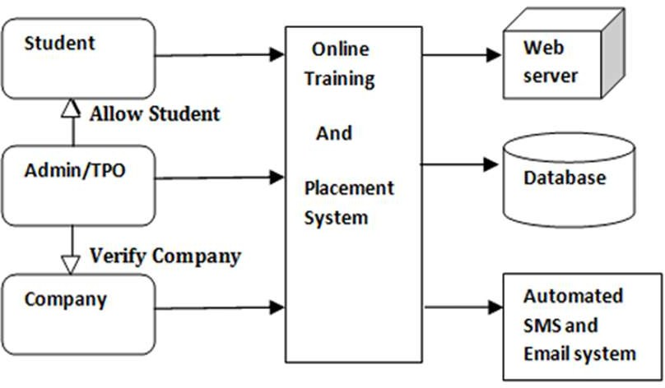

User Interface (Frontend)

* + Description: The frontend is responsible for presenting the user interface to students, recruiters, and placement officers. It allows them to interact with the system. The frontend includes web pages, forms for registration, job application portals, dashboards for placement officers, and recruiter management screens.
  + Technologies: HTML, CSS, JavaScript, ReactJS.

1. Authentication & Authorization
   * Description: This block handles user login, registration, and role-based access control. It ensures that only authorized users (students, recruiters, or placement officers) can access their specific features.
   * Functionality:
     + User registration (students, recruiters, placement officers).
     + Login and logout.
     + Role-based permissions (admin, recruiter, student).
     + Session management and token authentication (using JWT or OAuth).
2. Student Module
   * Description: This module manages the student’s profile, job application process, and tracking of placement progress.
   * Functionality:
     + Registration and profile creation (student details, resume upload).
     + Search and apply for jobs.
     + Track application status and placement results.
     + Communicate with recruiters and placement officers.
3. Recruiter Module
   * Description: This module is used by recruiters to post job openings, view student applications, and manage the recruitment process.
   * Functionality:
     + Job posting (title, description, skills required, deadlines).
     + Search and filter candidates.
     + Review student profiles and resumes.
     + Schedule interviews and manage the recruitment pipeline.
4. Placement Officer/Admin Module
   * Description: This module allows placement officers or administrators to manage student data, monitor the placement process, and communicate with both students and recruiters.
   * Functionality:
     + Manage student profiles, verify details, and monitor placement progress.
     + Handle placement statistics and report generation.
     + Coordinate interviews and placements.
     + Manage recruiter access and monitor their activities.
5. Database (Backend)
   * Description: The database stores all the essential data, including student information, job listings, application statuses, recruiter details, and placement outcomes. The backend serves as the central storage and data management unit.
   * Functionality:
     + Store student profiles, resumes, and application data.
     + Store job postings, recruiter information, and interview details.
     + Maintain data related to placement results and feedback.
   * Technologies: MySQL, PostgreSQL, or MongoDB.
6. Job Search & Recommendation Engine
   * Description: This block uses algorithms to recommend relevant job opportunities to students

based on their profiles, skills, and previous applications.

* + Functionality:
    - Match student profiles to job openings using skill-based matching.
    - Filter and recommend jobs based on location, salary, industry, etc.

1. Notification System
   * Description: The notification system keeps students, recruiters, and placement officers updated with real- time events, such as new job postings, interview schedules, application status changes, and placement results.
   * Functionality:
     + Push notifications for updates (e.g., interview invites, placement results).
     + Email and SMS notifications for important actions (e.g., job applications, profile updates).
2. Analytics & Reporting
   * Description: This module provides analytical tools and dashboards to monitor the success of the placement process, including student placement rates, recruiter satisfaction, and feedback collection.
   * Functionality:
     + Generate reports on placement success, recruitment trends, and student performance.
     + Analyze application trends to identify areas for improvement.
     + 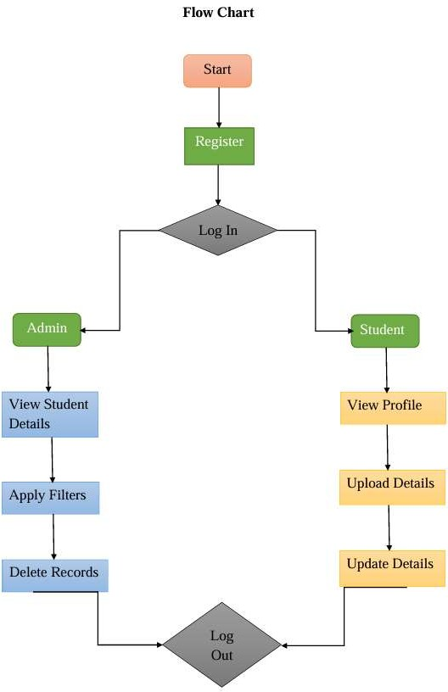Monitor and evaluate recruiter activity on the platform.

# CONCLUSION

MITRA represents a significant leap forward in modernizing the college placement process. By addressing the challenges of traditional placement systems, MITRA enhances the overall efficiency, transparency, and effectiveness of recruitment. Its intuitive design, automation, data security, and scalable infrastructure offer a comprehensive solution that benefits students, recruiters, and placement officers alike. The successful implementation of MITRA will not only improve the placement experience but also set new standards for college recruitment systems, ensuring that students are better prepared for their careers and organizations can easily find the talent they need.

As the platform continues to evolve, MITRA has the potential to become a cornerstone of college recruitment, reshaping the way students and employers connect, interact, and succeed.

# REFERENCES

Below is a list of references formatted according to the literature survey:

1. Suraj Trimukhe, Anil Todmal, Kanchan Pote, Monali Gite, Asst. Prof. S.S. Pophale, "Online Training and Placement System", International Journal of Advanced Research in Computer Science and Software Engineering. Volume 7, Issue 4, April 2017.
2. Prof. Rupali Komatwar 1, Swapnil Kamble 2, Mihir Khedekar 3, Kishor Walzade, “Placement Support System”, International Journal of Advanced Research in Computer and Communication Engineering Vol. 5, Issue 1, January 2016 ]
3. S. R. Bharamagoudar, Geeta R. B., S. G. Totad, "Web Based Student Information Management System", International Journal of Advanced Research in Computer and Communication Engineering Vol. 2, Issue 6, June